METHOD OF REGULATION AND SETTING OF THE CW-RTTY DECODER ON THE NOTE OF 800 HZ.

I wanted to create this small manual that will help you set up and adjust the digital mode decoder for Si473x – ESP32 receivers that mount the latest V 4.15 Air firmware.

Let's start from the condition in which you have already mounted the decoder board inside the receiver (ATS25 or homemade) or you have already mounted one of the new PCBs on which the decoder has already been mounted.

Once the receiver has been put into operation we need to make sure that:-

- The audio spectrum and the waterfall are visible, by clicking on the S-meter cyclically you will see in sequence the two types of S-meter (one analog with a pointer and one digital with BarLed), then the audio spectrum with vertical lines and finally the Waterfall with a graphic spectrum above it.

- We have to search on a HAM range, or on another known range, for a digital signal of which we are certain of its emission and its exact frequency (since we know that there are also very powerful stations which transmit in RTTY and CW including coastal stations, weather stations, etc. with known frequencies, my advice, especially for listeners throughout Europe and large parts of Eurasia, and North Africa, is to tune into the known frequency of 10100.80 Khz in USB where the DDH7 Weather station broadcasts - DDH2 – DDK9 from Hamburg - Germany which broadcasts, for all 24 hours, weather bulletins and for mariners, for the most part in the clear. For those who cannot receive the aforementioned station, they can look for another station in its vicinity, or tuning of CW signals transmitted by radio amateurs on the well-known HAM bands).

- Make the Waterfall appear on the screen, and depending on the signal received, choose the type of decoding.. that is… CW or DIGI . For CW mode we also have the option of having CW-R, (but for now let's limit ourselves to CW only). For RTTY, by pressing the DIGI button we will have the possibility to choose Rtty-L , Rtty-U and FeldHell (there is also the FT8 button… but at the moment, for this version it is still disabled) . I state that if you are tuning into Rtty Weather stations you must use Rtty-L decoding, while if you are tuning into Rtty HAM radio stations, then you must use Rtty-U…. this to have the possibility of always tuning on the first tone (the one on the left which is the mark… leaving the space tone on the right….obviously if you use Rtty-L with HAM emissions you will find that the decoding takes place on the tone on the right…) .

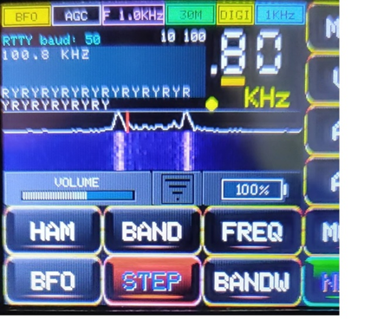

All this may seem not easy to understand, but when you practically do it you will notice that it is very simple (I assure you that it is more difficult said than done !!).

Having said that, let's set the volume of the receiver to a value of about 38 (the amount of volume also affects the quality of reception)…..let's start from a CW signal……(waterfall and CW mode)… as soon as we listen to a CW station we will notice the its classic "peak" and underlying line on the waterfall, at this point set the tuning step to 100 Hz (penultimate digit on the display) and with the encoder move the frequency until the peak approaches that red line you notice on the waterfall (this red line indicates that at that point tones at a frequency of 800 Hz are heard) … possibly with the pitch at 100 Hz you will not be able to perfectly center the red line, so change the pitch to 10 Hz (last digit on the display) and move very carefully until the tone matches the red line.

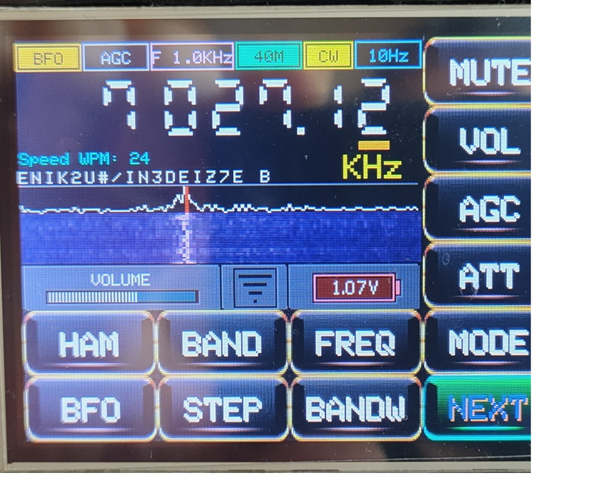

At this point you have two possibilities :-

1- You will see the small yellow LED at the bottom right of the frequency display flashing in a more or less evident way and you will see characters scrolling on the left side (possibly for the moment without any sense... or if you notice that you can already read the transmission, then the decoder is already perfectly tuned );

2- The yellow LED does not flash and you will not see any characters scrolling.

In both cases (nonsensical characters or LED not lit) move with the tuning to 10 Hz, in small steps both to the right and to the left of the red line (you will find it more easily on the left), until you receive the messages with complete meaning ... . So now you have the certainty of its functioning.

On the decoder with the resistance fixed at 15K, between pins 5 and 6 of the LM567 (for the ATS25), obviously you won't have the possibility to finely adjust the correspondence between the signal on the waterfall and the red line…. You will notice a small shift to the left of the signal in order to be decoded correctly (about 10-20 Hz), while whoever mounted the 20K multiturn trimmer (be careful it must be 20K, not 10k as I could see from some on the group who posted unsuitable schemes, this is because the 800 Hz note that must be "captured" by the LM567 is obtained with about 14.5 K (and varies in relation to the components used) ... with a maximum of 10K we will have the capture of a very high note ... about 1200 Hz… therefore well away from the red line) can safely bring the waterfall signal to match on the red line and then adjust… very gently… the 20K trimmer until you receive the text perfectly with complete meaning.

Once everything has been adjusted, as indicated above, you will see that even when tuning an Rtty signal it will already perfectly match the red line (always on the tone mark… as mentioned above).

There is one last thing to say…. Obviously you will notice that to decode exactly you will have moved in frequency… even by a hundred Hz… in fact if you are receiving the aforementioned Rtty weather station perfectly (red line matching with the signal) .. instead of 10 100.80 the frequency will be indicated by the display for example 10 100.10… to get the precise reading on the display, do this:-

- Calculate the offset in Hz (in the example above we will have a offset of -700 Hz);

- Activate the BFO key and add…. or subtract, as needed, the 700 Hz from the already present BFO value… go back to the frequency display and bring the frequency back to 10 100.80… you will notice with pleasure that now you will have a precise correspondence between :- frequency – signal – red line – exact decode.

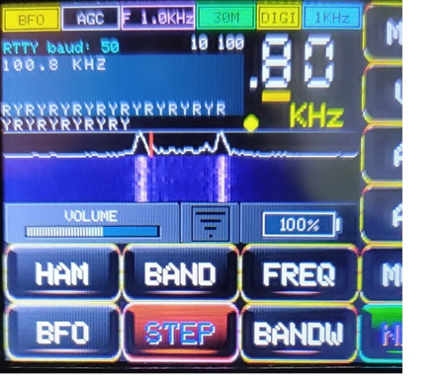

Done !!